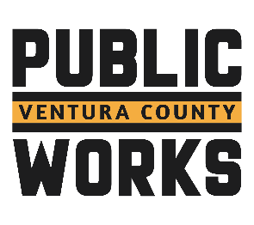
Request for Statement of Qualifications

The Ventura County Roads & Transportation is soliciting Statements of Qualifications from qualified firms to provide environmental services for the Matilija Canyon Road Storm Damage Repairs @ MP 2.25 and Matilija Canyon Road Slope Repair MP 0.30 TO 0.52 Projects. Funding for this project is actively being pursued through FEMA Emergency Relief Programs. The selected Consultant will be required to prepare the appropriate Federal, State, and local environmental documents to obtain CEQA & NEPA clearance.

Copies of the Request for Qualifications (RFQ) can be obtained by contacting the County of Ventura, Public Works Agency, Roads & Transportation at 805-477-1975. Proposers may submit questions via email to Christopher.Solis@ventura.org no later than 2:00 p.m. by August 9, 2024. All requests for information and answers will be posted on County’s website. It is the responsibility of the proposer to monitor the website for updates.
The RFQ includes a description of the services to be provided, contents of the responses and the factors used to evaluate the responses. The County reserves the right to change the solicitation schedule or issue amendments to the solicitation at any time. The County reserves the right, at its sole discretion, to waive immaterial irregularities contained in the solicitation. The County reserves the right to refrain from contracting with any respondent.
All responses to the RFQ must be submitted by 2:00 p.m. on August 16, 2024. For more information, please contact Yvette Perez at 805-477-1975 or by email at Christopher Solis@ventura.org

